Name : Saurabh Sanjay Jadhav

Topic : IAM in AWS

Assignment no. : 14

1. Create a user using GUI
2. Navigate to IAM dashboard and click on create user.

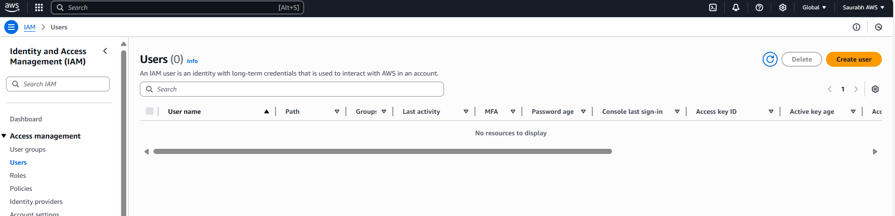

1. Provide username “saurabh” and check the box for users access to aws console. Mention custom password for user.

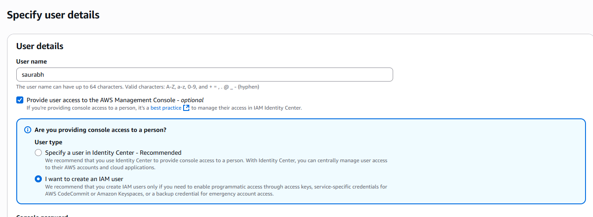

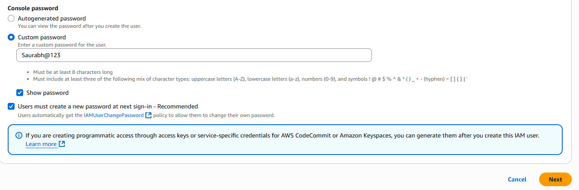

1. Set the permissions for user. Provide full access to S3 bucket.

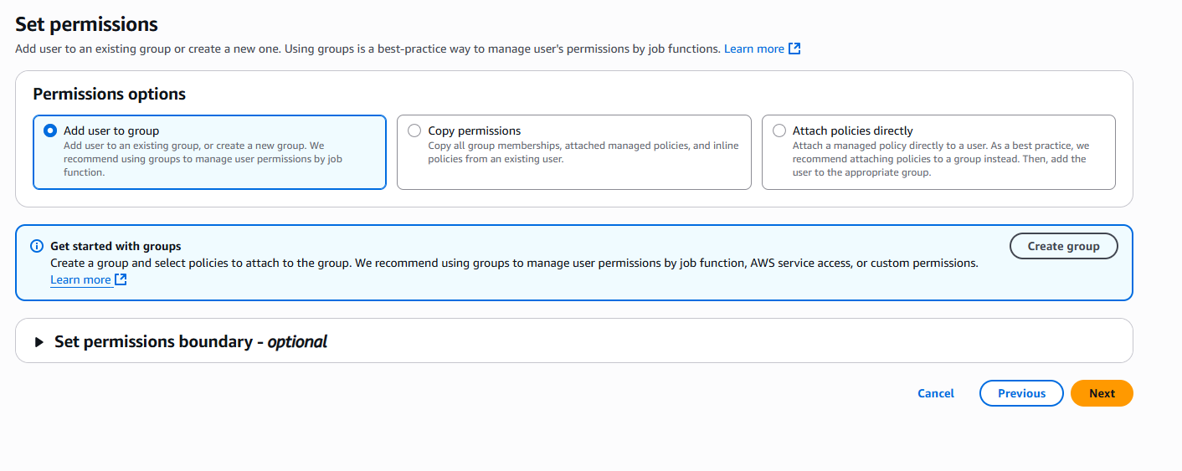

1. Review the user details and click on create user.

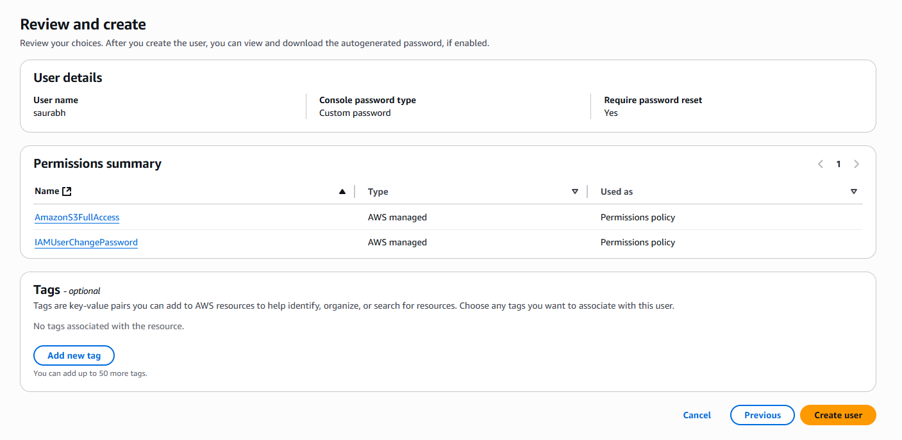

1. While login with user “saurabh” it will ask for password change during 1st login.

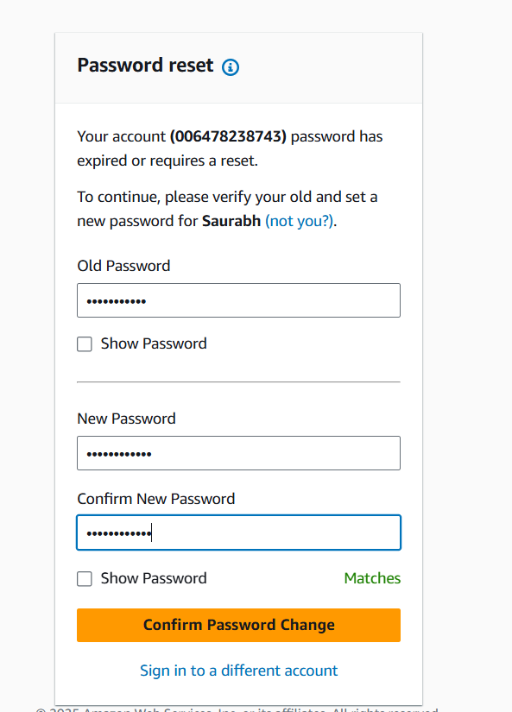

Successfully logged in.

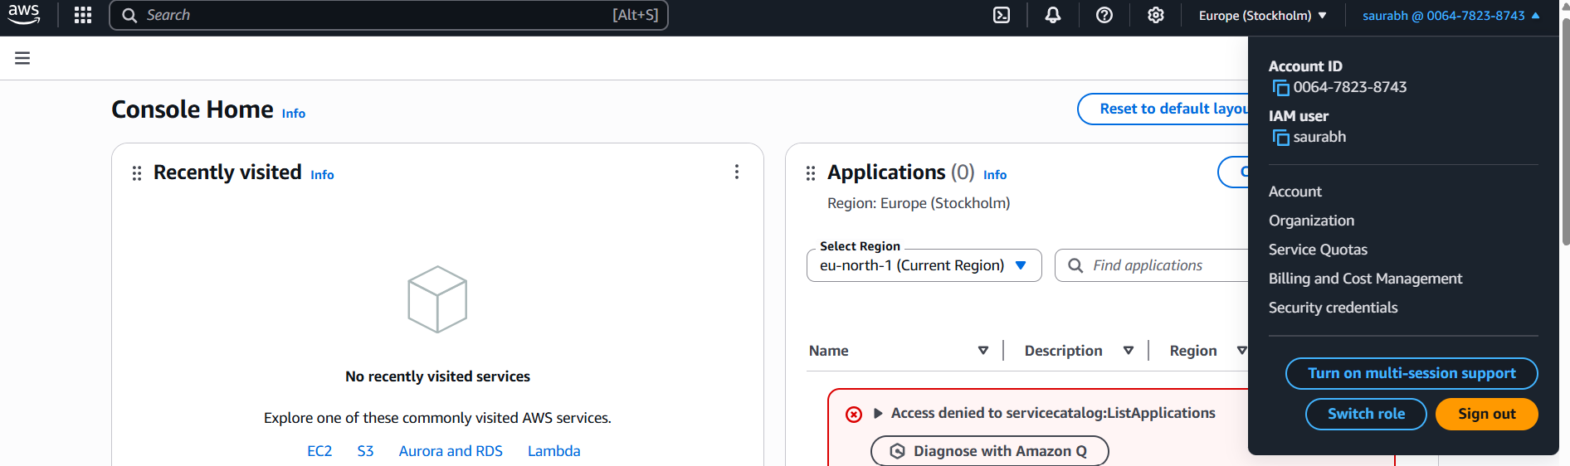

1. Create S3 bucket with user “saurabh”.

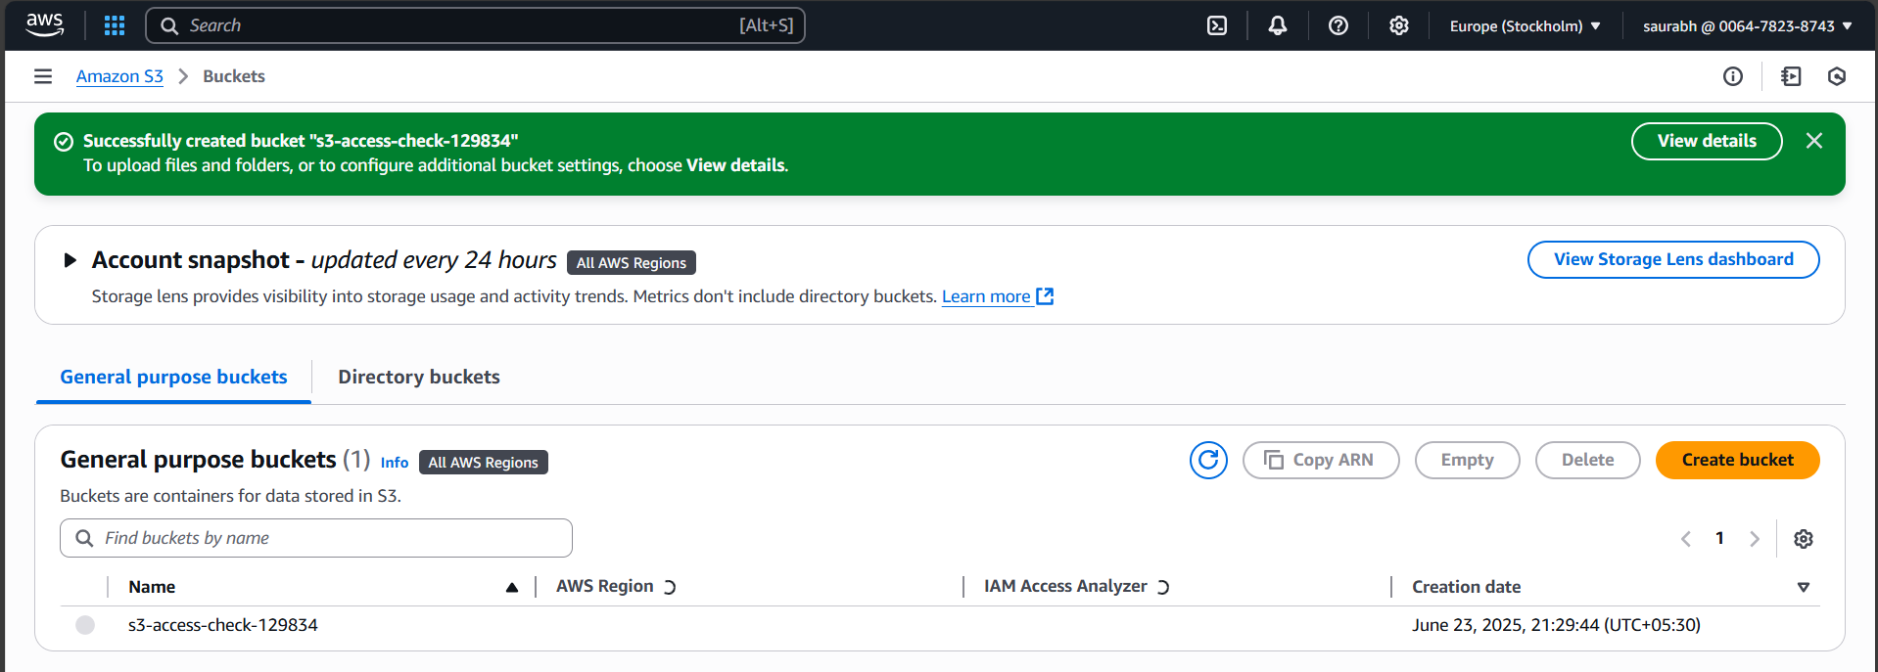

1. Create group with full access to EC2.

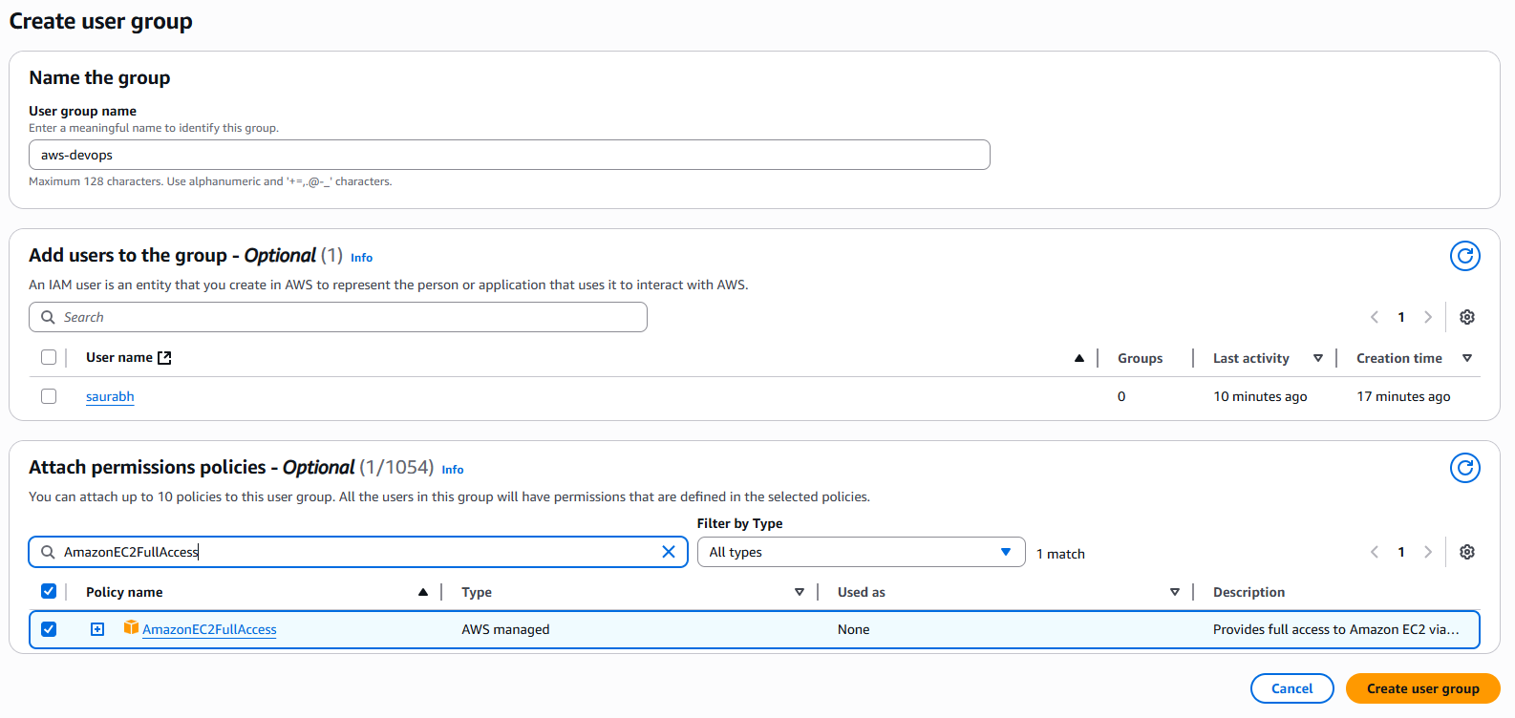

1. Create another user “pratik” and add him in the group “aws-devops”.

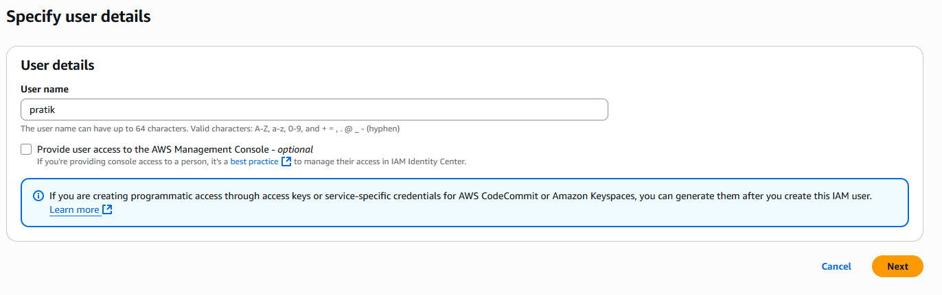

Add permission to user “pratik” for s3 bucket.

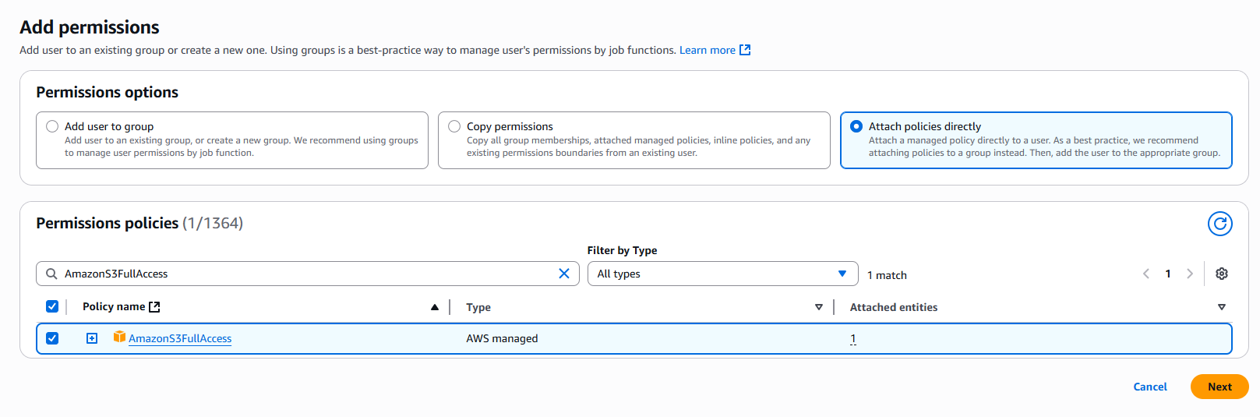

1. Create EC2 instance in which we will login using user “pratik” and create s3 bucket.
2. Create access key for “pratik”.

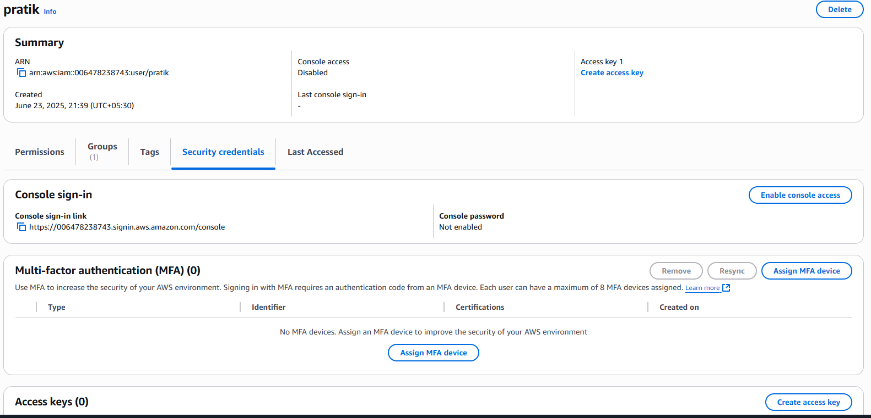

1. Used for CLI access.

1. Copy the access key and download file.

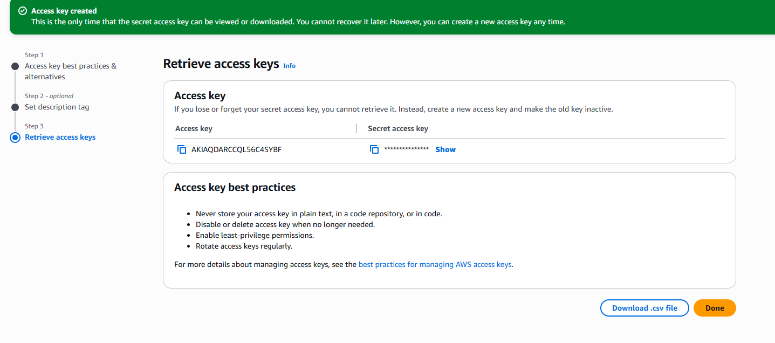

1. Connect to ec2 instance.

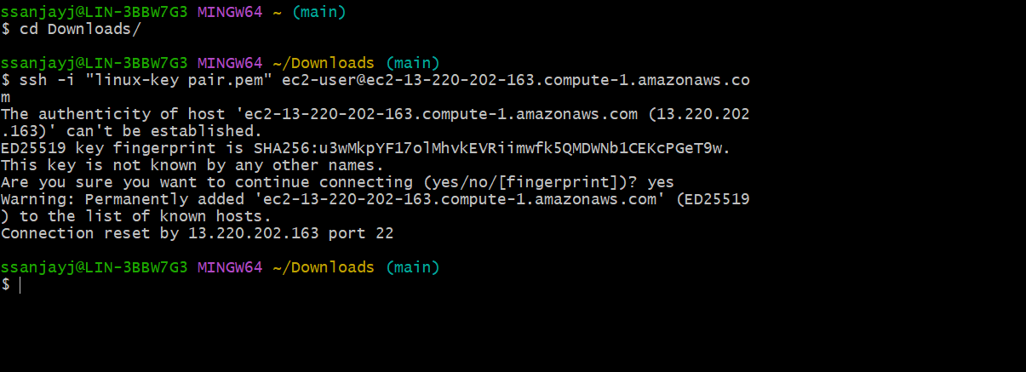

1. Configure aws cli



1. Create s3 bucket with CLI

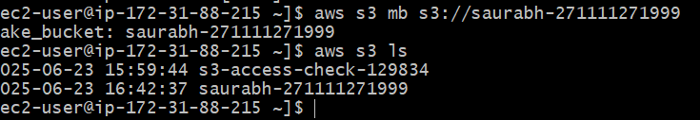

1. Remove s3 bucket

